Inconsistent Security between Matter and underlying Documents:

Found this issue in Production:

Matter: AMG145/US/466

Matter Security shows as follows:

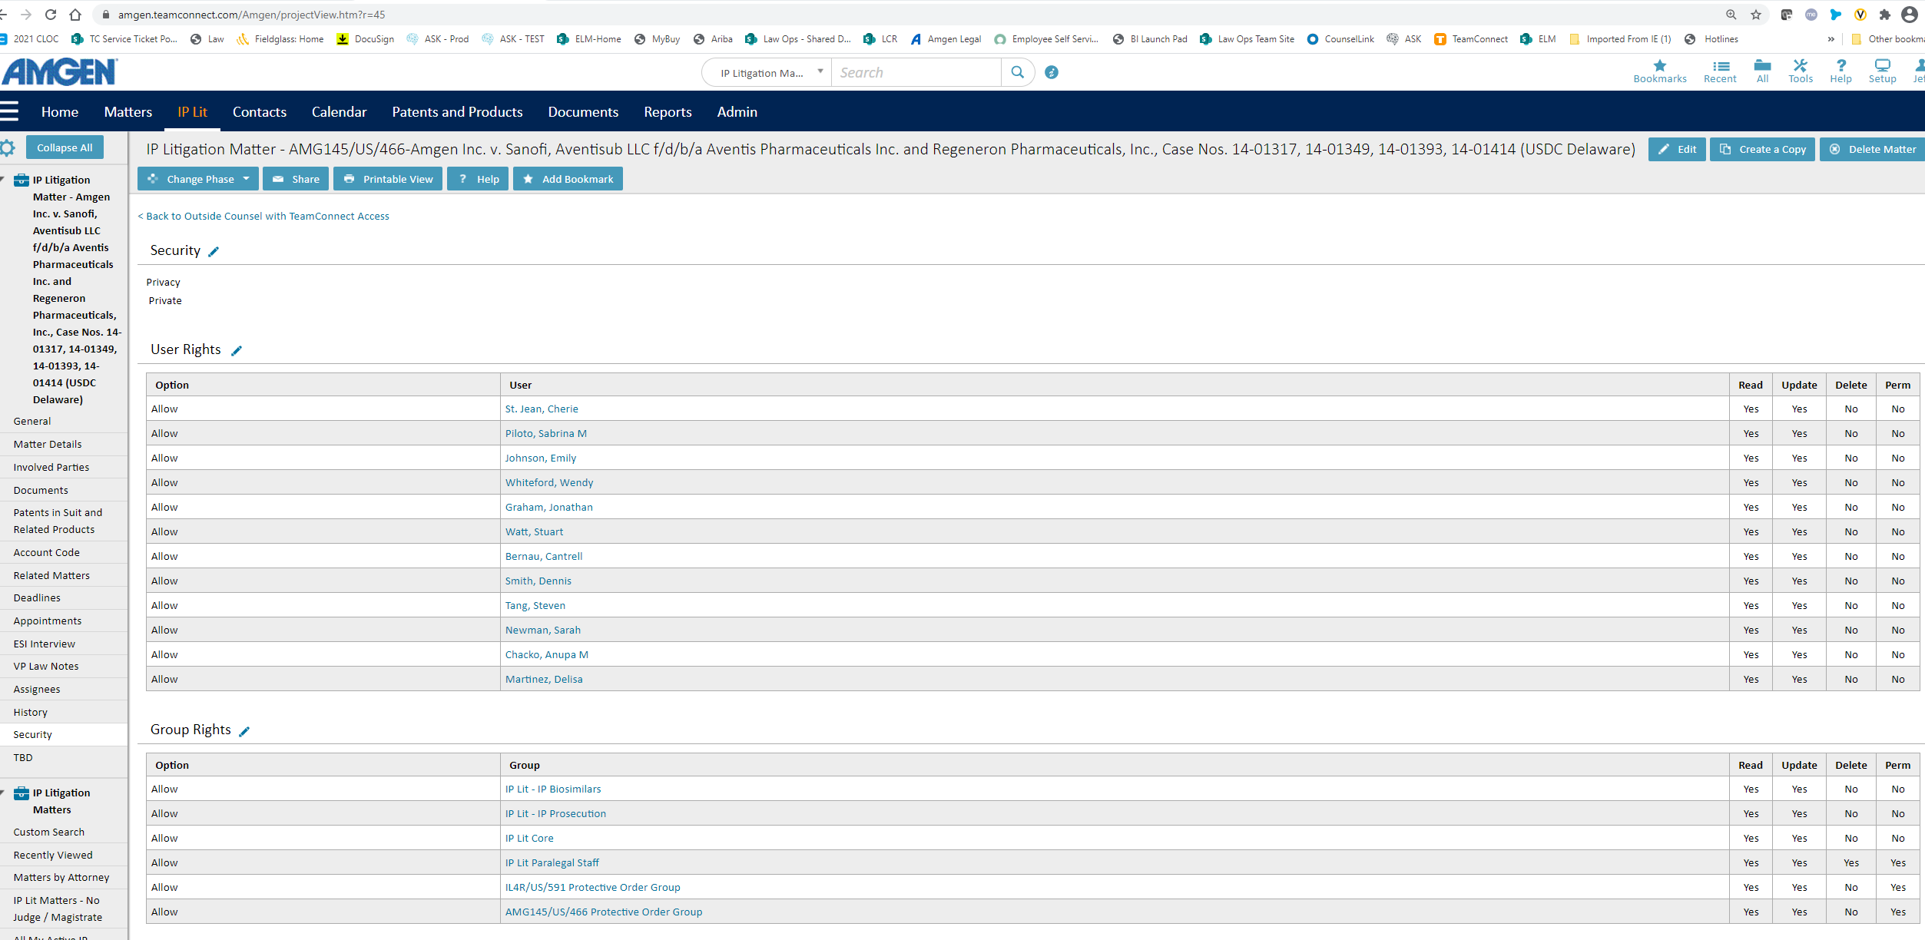

Assignees tab:

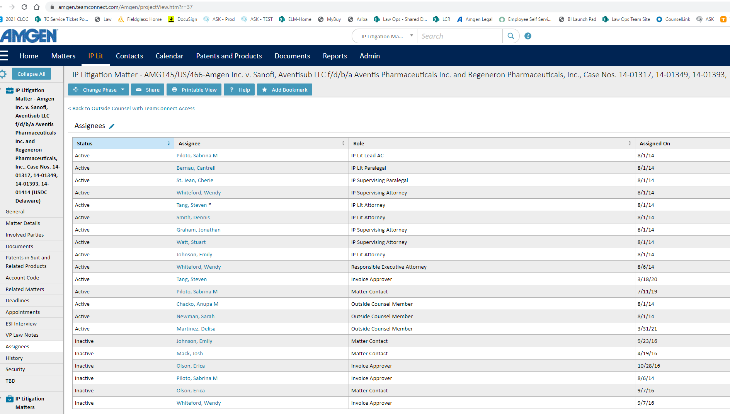

First Document ([Attachments](https://amgen.teamconnect.com/Amgen/DOCU_323165) » [Work Product](https://amgen.teamconnect.com/Amgen/DOCU_589778) » [112 Work Product](https://amgen.teamconnect.com/Amgen/DOCU_363273): [(WP-112) amgen.regeneron patents summary.docx](https://amgen.teamconnect.com/Amgen/DOCU_418384)):

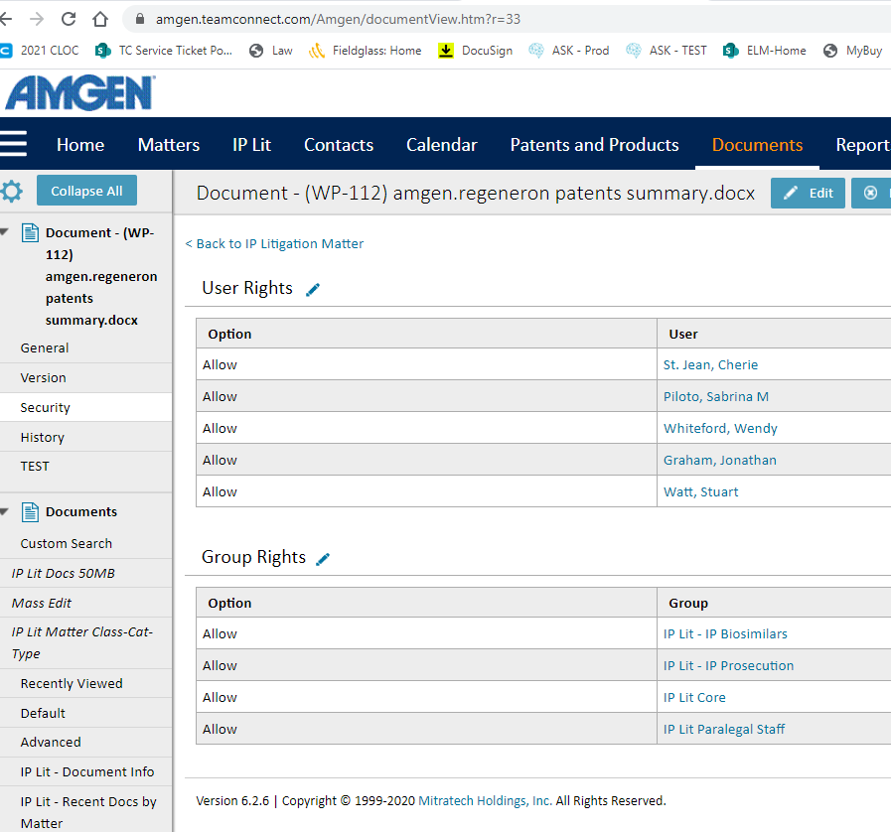

Second Document (Folder: [Attachments](https://amgen.teamconnect.com/Amgen/DOCU_323165) » [Trial](https://amgen.teamconnect.com/Amgen/DOCU_326749) » [2019 Trial](https://amgen.teamconnect.com/Amgen/DOCU_385043)):

